**Daily Submission**

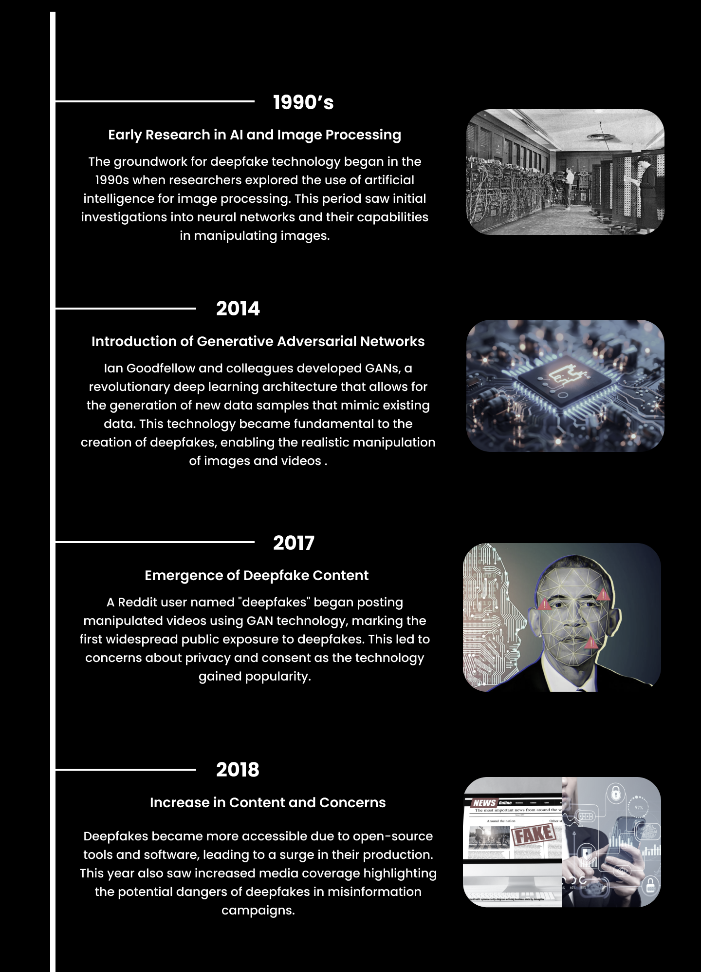

Code:

